**License Assignment**

In this assignment, you will be creating an application that will allow users to create licenses for every person.

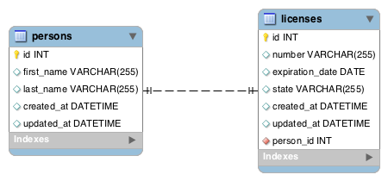

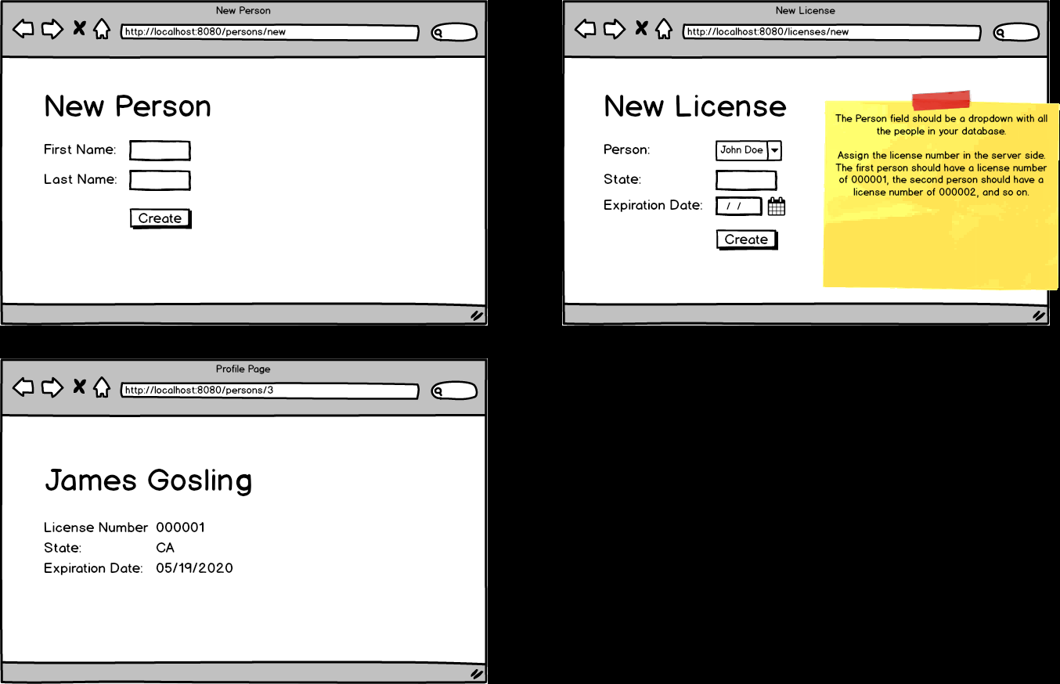

Topics:

* 1:1 relationships
* JPA methods

Tasks:

* Allow users to create a new person with their first name and last name
* Allow users to create a license with the state and expiration date; however the license number is done by the server. The first person in the DB has a license number of 000001. Increment by 1 every time a new person is added.
* Have a person's show page that will retrieve their name, license number, license state, and license expiration date